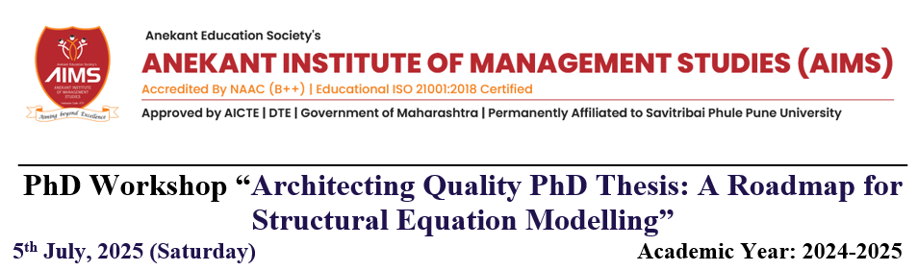

AIMS Research Centre has developed a one-of-a-kind program for the academic year 2024-25 known as the "Guide's Initiative". Under this effort, we held a one-day workshop for Ph.D. students enrolled at several research centers in and around Baramati.

We received a tremendous response to the Online Workshop. More than fifty PhD students actively participated in the program. Students from PhD research centers in Vidya Pratishthan Baramati, SVPM Malegaon, TC College Baramati, ADT Group Campus in Shardanagar, and Nevellie Wadia Pune participated in the workshop.

Students from Maharashtra, Gujarat, and Uttar Pradesh attended, making it a true national-level program.

Dr. Madhavi Damle (Assistant Professor - Symbiosis Institute of Digital and Telecom Management, SIDTM) is well-known for her skill in Research Methods, which leads to high-quality PhD research. She recommended "Architecting Quality PhD Thesis: A Roadmap for Structural Equation Modelling" as the workshop theme. Dr. Madhavi Damle served as the workshop's subject matter expert, and her presentation received positive response.

This activity was much appreciated by Dr. Harshwardhan Vhora, Secretary AIMS, Dr. Preetam Vhora, Member GC, Dr. M. A. Lahori, Professor Emeritus, and Dr. Dhanjay Bagul, Director AIMS. Dr. Abhishek Dikshit, Associate Professor at AIMS Baramati, coordinated the program.

